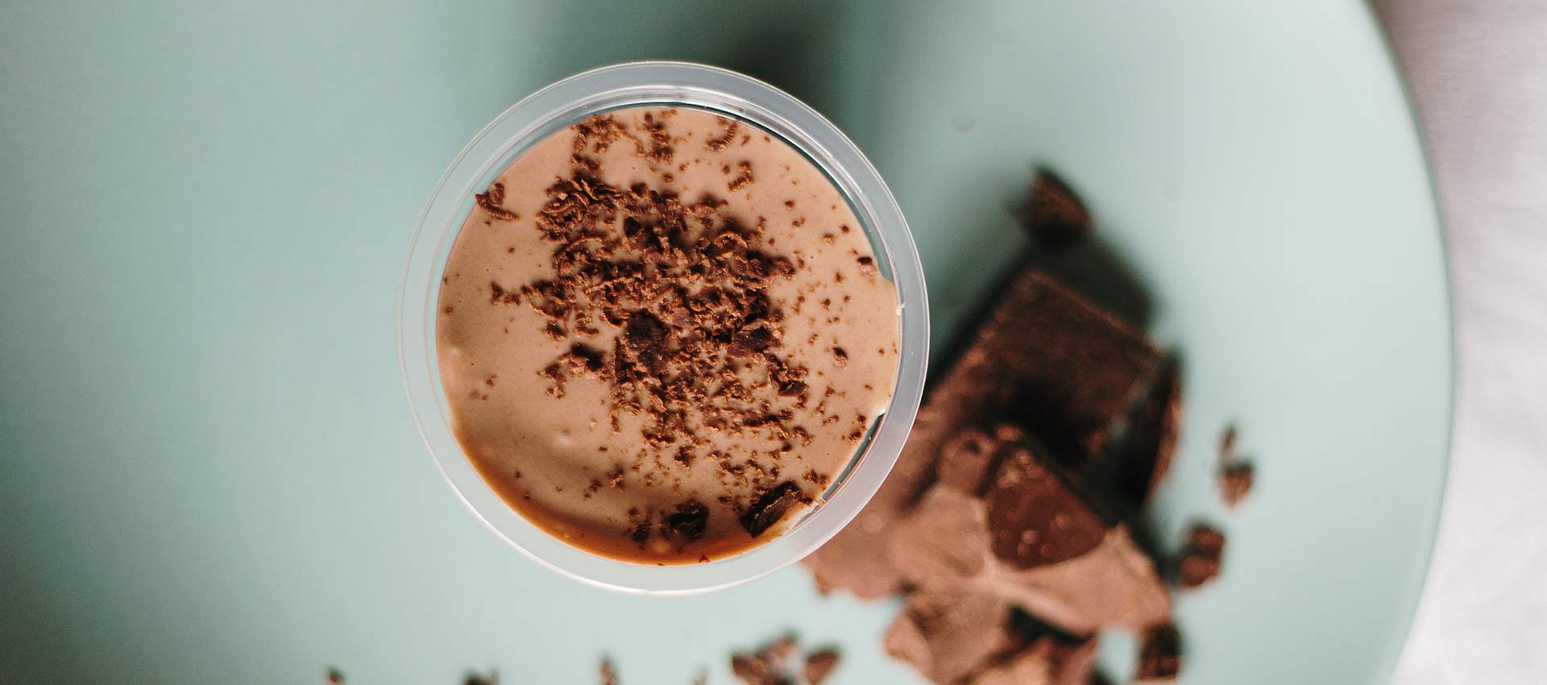

Chocolate Drinks in Pakistan – Bringing richness of nutrition and taste to your diet

Milo

Milo, it’s the most trusted chocolate malt Beverage Company. The yummy taste and trusted quality of Milo have made it embark its name into the industry since the early 1930s when it was first launched in Australia. Right from the start, Milo has encouraged children to take part in sports and that’s how they’ve been advertising their product.
The preparation of this mouthwatering chocolate malt beverage is really simple and easy. Anyone from adults to children can make it on their own. You simply need to add the powder into milk or water and stir it up and your milo drink will be ready.
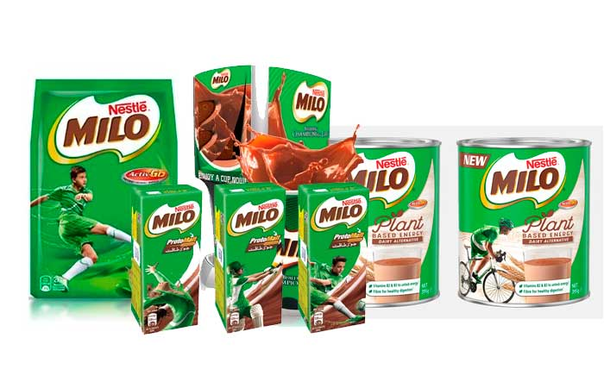
You can also make it in cold water and milk depending on your mood and taste. Milo is enriched with all the essential vitamins, minerals and sugars which are necessary for the growth and helps in keeping your body healthy. It is very beneficial for the growth and development of young minds and bodies.

Is it good for you?

Milo is an energy chocolate malt beverage which is enriched with multiple essential vitamins and minerals like:
- Calcium which is very important for strong bones and teeth
- Iron which helps in carrying oxygen to different cells in the body
- Vitamin A which is essential to have healthy eyesight.
- Vitamins B1 and B2 which helps the body in releasing the energy from the foods.
- Vitamin C which helps in keeping your gums and skin in a good shape.

Is there any disadvantage?

In 2018 Milo faced a backlash by the health experts which dropped its 4.5-star rating. This is because Milo has a high content of sugar in it along with all the minerals. This might not result in that bad in children but still, high sugar intake is discouraged as it results in obesity and high blood pressure.
Milo is considered to have a high number of carbohydrates and can be bad for a diabetic person. However when the powder is mixed in milk the glycemic rate decreases. That’s why experts suggest having a moderate intake of Milo.

Ovaltine

It is a perfect combination and a real good mixture of malt and milk. With amazing three different and tasty flavors Ovaltine is leading the market with its name in manufacturing healthy and nutrition filled drinks.
A single sip of Ovaltine will take you back to your childhood and each sip will be heavenly good for your body in terms of nutrition, vitamins, and energy. It is a perfect blend of 12 vitamins and minerals without having any sort of artificial flavor or sweeteners. 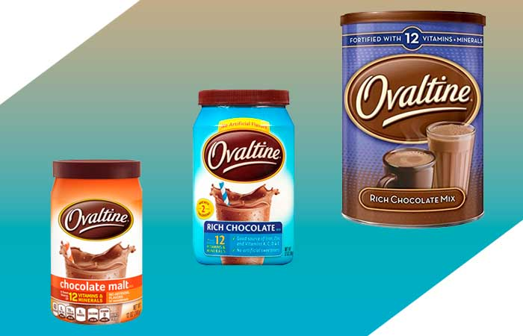
The powder doesn’t only go well with your chocolate drinks but is equally tasty and tempting in smoothies, baking or even if sprinkled on ice cream.

Is it good for you?

Ovaltine has a wide range of essential vitamins in it like Vitamin A, Vitamin B, Vitamin C, Vitamin D, Vitamin E, Vitamin K, Vitamin B6, and Vitamin B12. Along with all the vitamins it’s also filled with some important minerals like Iron, Magnesium, Calcium, Potassium, Sodium, and Zinc.
The drink also has many other minerals, vitamins and fat content which is very essential for human growth and development. Each glass of Ovaltine gives you 170 calories and fills 35% of your body’s calcium intake.
In a world full of artificial flavors and foods you can fulfill your body’s natural mineral and vitamin needs with a daily intake of Ovaltine which is not the only nutritionist but also has the best taste.

Is there any disadvantage?

Despite all the advantages and being a full stocked vitamin and mineral drink Ovaltine was banned in Denmark in 2011. The drink wasn’t banned because of any inappropriate or wrong claim but because it had a high content of vitamin B and because of the strict food policies of Denmark the drink was banned along with many others.
However, the drink still doesn’t show any disadvantage or doesn’t cause any diseases to date. It is loved for its amazing taste and is for sure a healthier choice.

Cadbury chocolate

People have been a fan of Cadbury chocolate for years now. Especially if we talk about Pakistan then Cadbury chocolate has taken the market share of almost all the national chocolates of Pakistan like Now, Jubilee, etc.
After keenly observing the want of its chocolate Cadbury decided to launch its powder drinking chocolate in Pakistan. With its heavenly taste, Cadbury drinking milk has become the favorite hot chocolate drink of all the Pakistanis.
The preparation of hot drinks is quite simple. You can either add 3 heaped teaspoon of Cadbury drinking powder into a mug of semi-skimmed hot milk or stir it till the milk froths and the powder completely dissolves or can simply add it directly into the semi-skimmed milk, then heat it in the microwave and stir it.
. 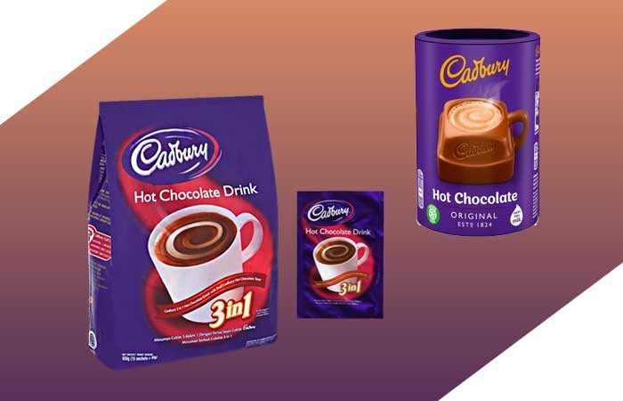
You can also use the powder in baking, garnishing your desserts, etc. Its perfect chocolaty taste will only enhance the flavor of your milk or desserts with its heavenly chocolate taste and aroma.

Is it good for you?

Not only does the Cadbury Drinking Milk tastes heavenly but it also has a perfect blend of necessary fat and energy which is essential for your body. The drink isn’t only a pleasant treat for your taste buds but also gives you the energy to fulfill the tasks more energetically.

Is there any disadvantage?

So far there isn’t any disadvantage of drinking Cadbury drinking chocolate. Infect the buyers of the product are increasing because its yummy taste encourages the habit of drinking milk in children.

ENSURE

It is one of the trusted brands in Pakistan when it’s about having a drink full of flavor and nutrition’s then Ensure is the only choice of the doctors and the people. Ensure is basically for the people who are above 18. The brand has launched the same healthy drink for children as well it is named PediaSure.
Pediasure helps children in their mental and physical development. It also shows some amazing results in growing the height of the children. However Ensure is specifically for adults.
Ensure is a perfect blend of all the necessary nutrition your body wishes to intake in order to strengthen your immune system. Therefore most of the doctors in Pakistan recommend it to people who are underweight or sick.
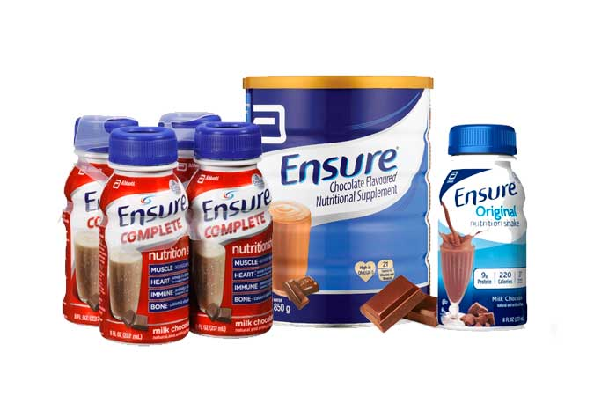

Is it good for you?

Ensure has a wide range of essential vitamins in it like Vitamin A, Vitamin B, Vitamin C, Vitamin D, Vitamin E, Vitamin K, Vitamin B6, and Vitamin B12. Along with all the vitamins it’s also filled with some important minerals like Iron, Magnesium, Calcium, Potassium, Sodium, and Zinc.
The national value of ensure is high above any other healthy drink. It is best for the people who cannot have a proper appetite through the solid intake. That’s why most of the doctors today recommend the patients to have to Ensure twice a day. They even recommend the patients to have it instead of a meal because of its full nutritional value.

Is there any disadvantage?

To date, there is no disadvantage of having Ensure. Infect the doctors and many other well-known nutritionists have claimed it as a trusted healthy drink for adults. This is because it has all the necessary nutrition, minerals, and vitamins that are essential for you as your body grows.

